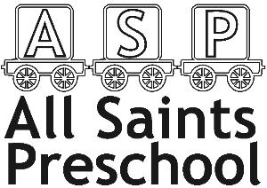
All Saints Preschool
c/o All Saints Primary School
St Catherine’s Road
Winchester
SO23 0PS
allsaintspreschool@hotmail.co.uk
07871195724
Newsletter – March 2017
Our interests Our interest for this half term is ‘Dinosaurs.” Thank you to Becky Butler for the Donation of our Giant Climb On Dinosaur to go with our dinosaur land outside. The children have been having fun feeding the dinosaurs’ pasta and doing dinosaur foot step printing, dancing, mark making etc.
Outside play We hope you have all enjoyed the snow, we have loved the pictures that have come in and talking to the children about what they did in the snow. Please provide a change of clothes as we are running low on spare pants, socks and larger trousers. We have water play outside and the children do go outside in the rain. A waterproof coat is also needed in wet weather, if possible waterproof trousers would be great.
Please label your Childs bags, Coats, bottles, lunch boxes and clothing!
Easter egg hunt event Thursday 29th march (our last day) will be our Easter egg hunt and raffle. We would like donations of raffles prizes including eggs, cuddly toys and treats. We would like to ask if you could bring them in after Monday the 26th as we do not have enough storage space. Parents are to arrive at 11 o clock to take part in the Egg Hunt and Raffle with your child.
TAPESTRY Thank you for all your support and patience with the tapestry. We are so pleased with the observations that have been done so far and hope you are enjoying your Childs online journals. If you have not yet activated your account please let us know.
LATE FEES Could you please make sure you collect your child at the right time. We have issued a few late payment fees recently and would like to avoid these in the future. After 5 minutes of being late you are charged £2 for every further 5 minutes. When children are picked up late this impacts on staffing. In particular, staff having to stay longer than there working hours and other hall users are booked in to use the hall so we need to finish promptly.
HEALTHY LUNCH We have noticed that lots of lunches are not suitable for preschool. It is an Ofsted and Government Requirement that children have a well-balanced and nutritional lunch. It is our responsibility as preschool professionals to make sure parents are aware of the healthy choices.
From April the 16th only water or sugar free squash (very diluted) will be accepted. Any other juice drinks, fruit shoots etc will be put away and water will be given to your child. A small pack lunch is better than a full lunch box which should contain a carbohydrate and fruit. We will provide advice on lunch box ideas and good choices. We also have the board next to the name tree with advice. We will be providing the correct amount of daily physical movement within preschool where possible to support you as well as a healthy snack.

TRIP letters are coming out to all parents about a trip we are planning for Thursday 14th June to ‘4 Kingdoms’. Please can you sign and bring back the permission slips as soon as possible so we can make all the final arrangements.
HAPPY EASTER FROM ALL OF THE STAFF AT PRESCHOOL!!
TERM DATES/INSET DAYS
BANK HOLIDAY - Good Friday 30th March
HALF TERM starts Thursday 29th March
SPORTS Day -Thursday 17th May
TRIP– 14th June ‘4 KINGDOMS’
OPEN DAY -Friday 18th May (to be confirmed)
END OF TERM –Friday 20th July (The End Of Term Leavers Ceremony will be one day in this week)
FUTURE INSET DAYS-Monday 23rd July, Monday 3rd September, December 19th, 20th and 21st
PHOTOGRAPHER - Thursday 15th November 9-11 o clock
Don’t forget, any problems, concerns or questions, just ask! We are all happy to help. This includes the free 30 hours childcare and 2 year funding.
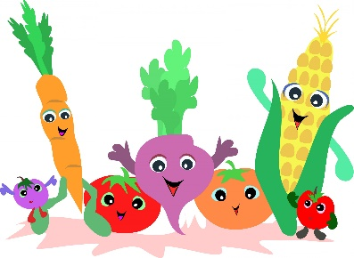
Healthy Pack Lunch Ideas
Savoury
- Banana sandwich with wholemeal bread
- Tuna and sweetcorn wholemeal roll
- Pasta and sausage salad (with spring onion and red pepper)
- Cheese, ham and lettuce pitta pocket
Dairy/puddings
- Low-fat fruit yoghurt
- Low fat fromage frais

Drinks
- Sugar free squash
- Water

- Houmous, red pepper and grated carrot wrap
- Egg and tomato roll
- Rice/oat cakes and cream cheese

Side portions
- Tomato’s
- Carrot/cucumber/pepper sticks
- Boiled egg
- Cheese cubes
- ½ piece of fruit or handful of grapes
- Small box of raisins

Healthy foods?
Here are some examples of foods and drinks that you may think are healthy alternatives for your child however looking at the contents you can see they are not.
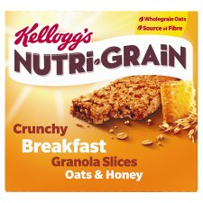
These contain (per roll): 6.3g of sugar and 1.4 g of fat

Per bar: 6g of sugar and 3.6 g of fat
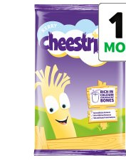
1 cheese string: 4.5g fat and 0.4g salt

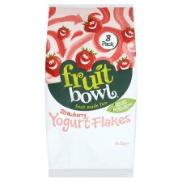
1 25g bag: 4.8g fat and 16g sugar

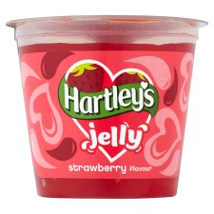
1 pot: 23.2g Sugar and 0.3g salt

1 tube: 5.6g sugar and

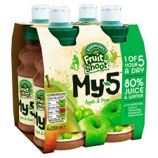

Per bottle: 18g sugar

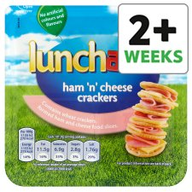
1 sausage: 11g of fat and 0.8g Salt

Per pack: 11.5g fat and 1.76g salt

Children should have NO MORE than (per day):

- 12 grams of sugar
- 20 grams of fat
- 1 gram of salt

