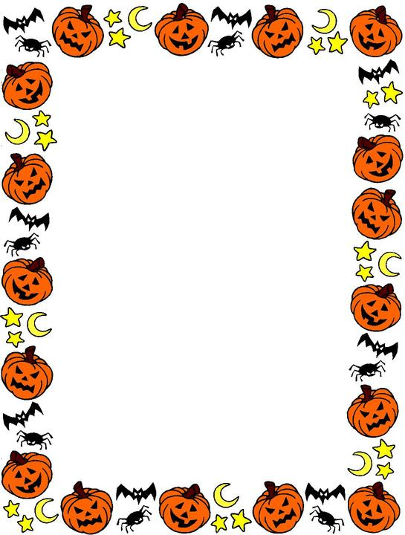

9-10am aam

**All Saints Preschool**

Children and parents

Pumpkin carving

&

Crafts morning

Bead spiders Slime paper 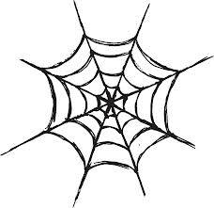 colouring

Tuesday 19th of October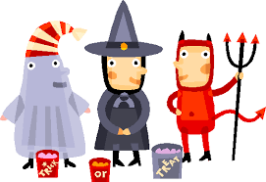

Feel free to dress up in

Your favourite Halloween costume!! (Will be messy)

Donations appreciated (to cover costs)

Just turn up in your favourite Halloween outfit!!



**All Saints Preschool**

Children and parents

Pumpkin carving

&

Crafts morning

 bead spiders Slime paper  colouring

Tuesday 19th October

Feel free to dress up in

Your favourite Halloween costume!! (Will be messy)

Donations appreciated (to cover costs)